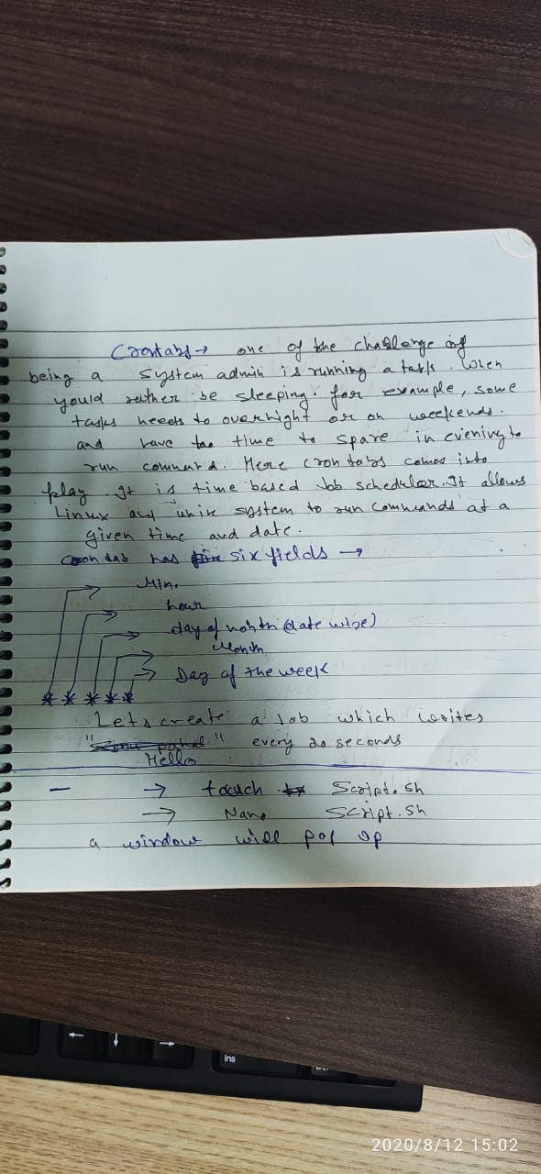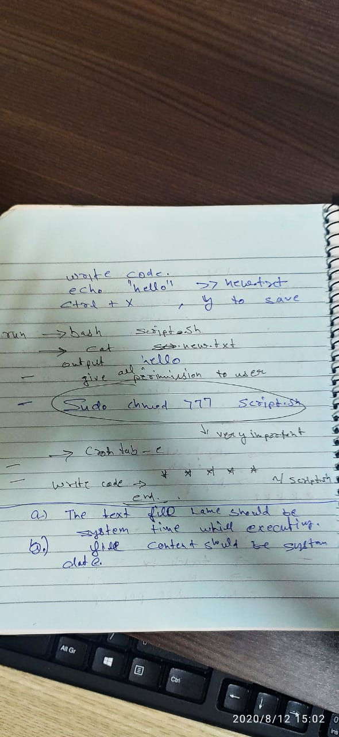

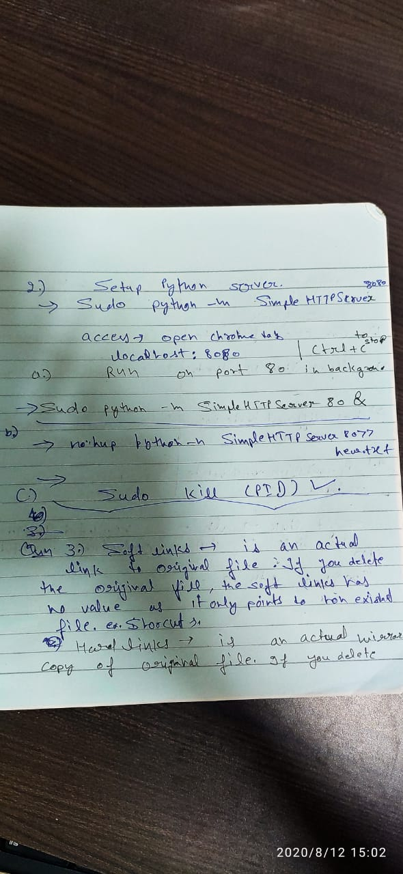

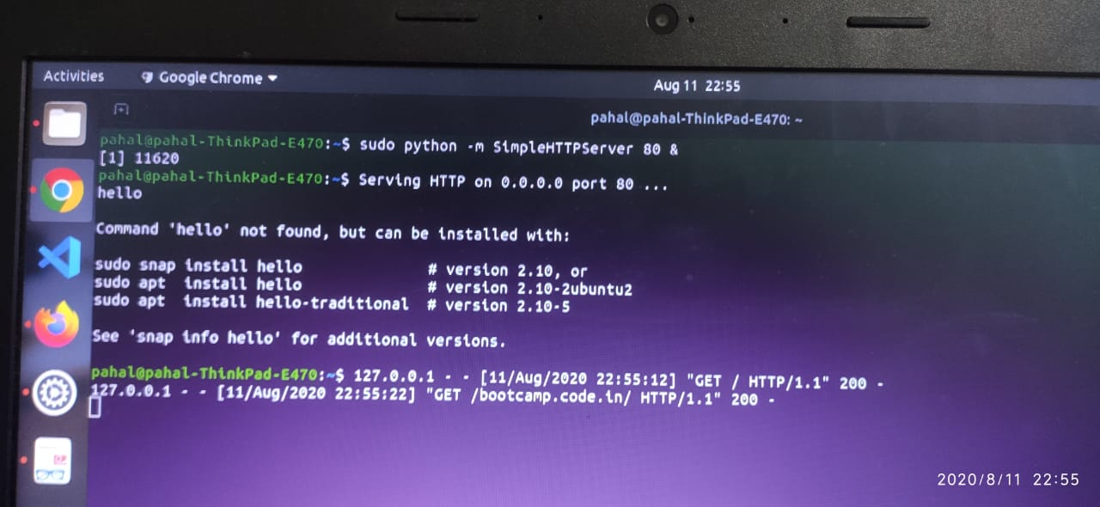

Python Server in background

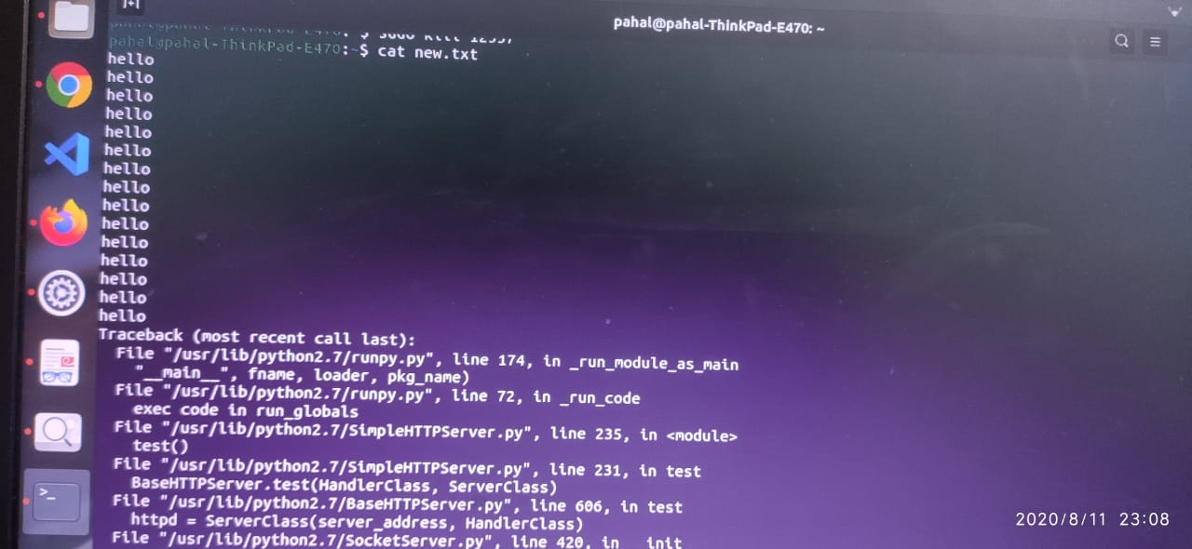

Python Server output in new.txt

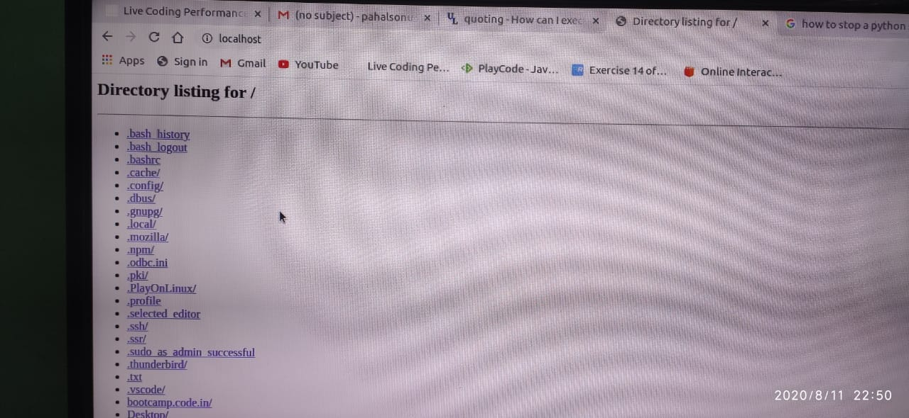

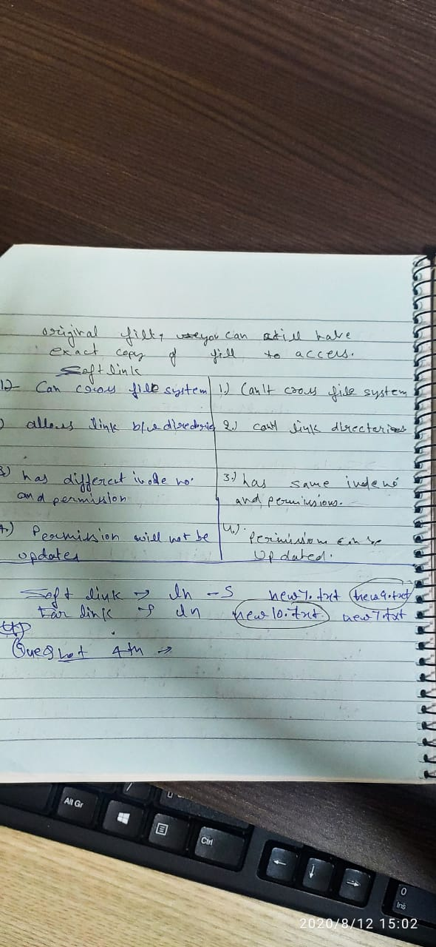

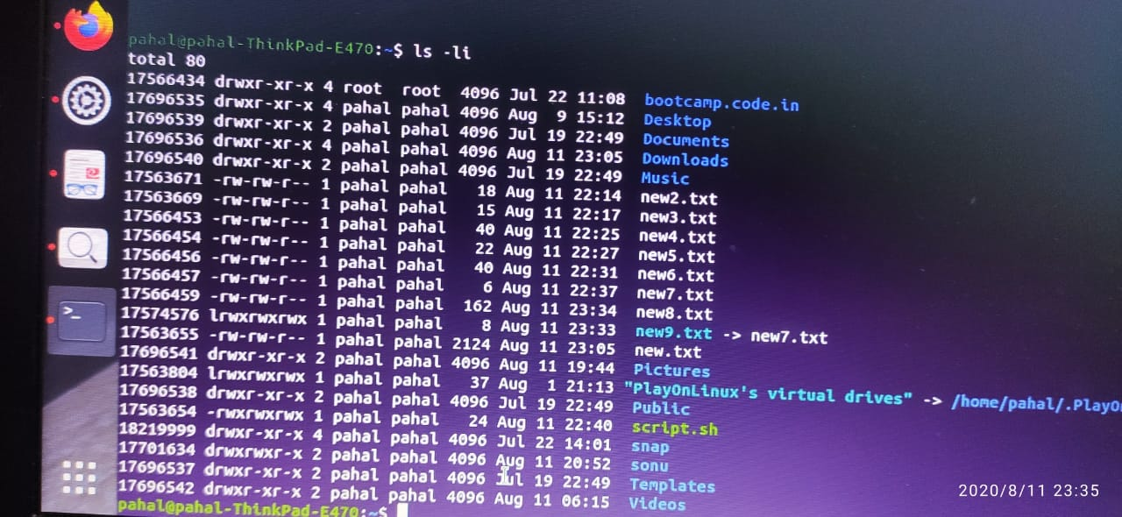

Soft link

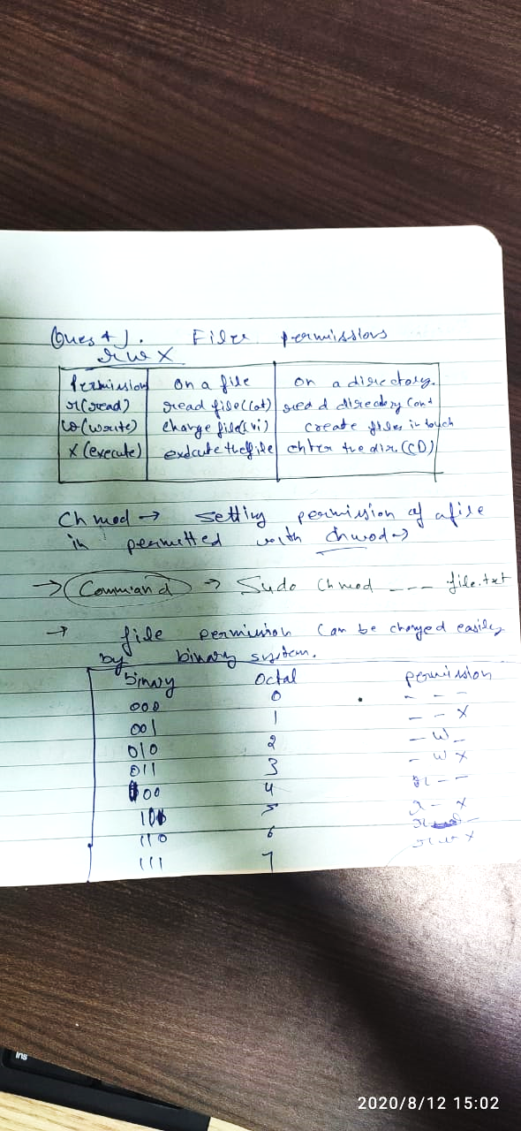

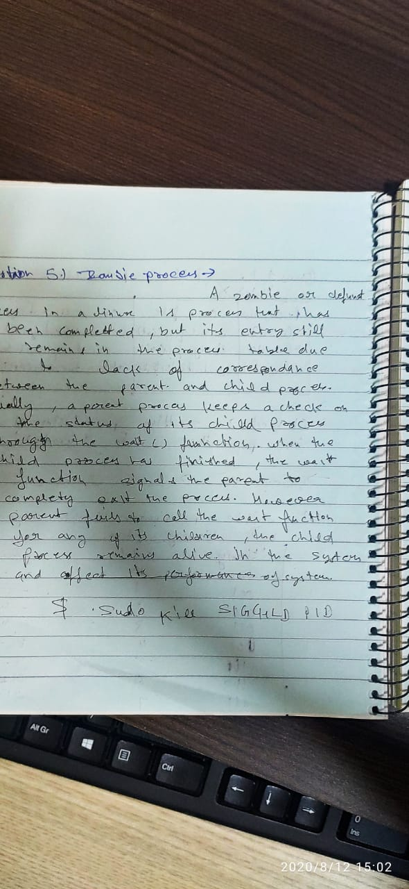

**Question no. 6**

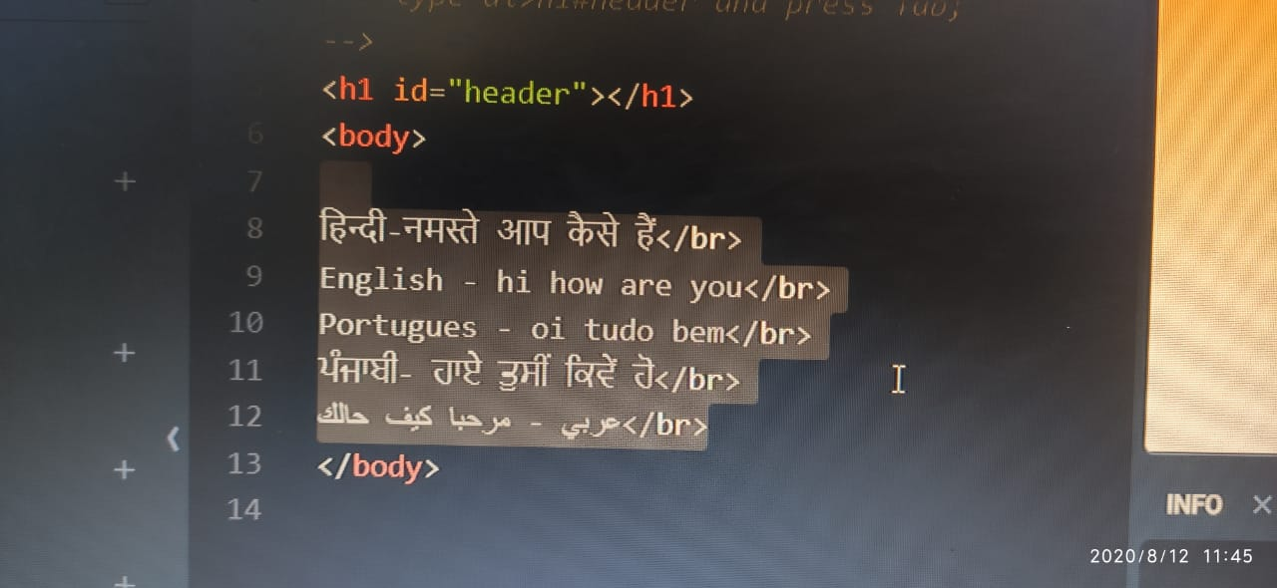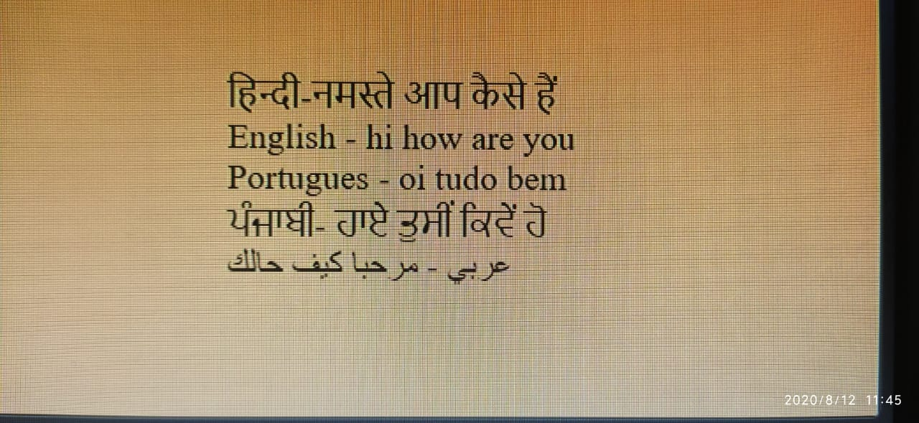

**Things i have Learned**

**Internet basics**

1. HTTP Requests
2. IP Adresses
3. Servers

**HTML**

* Stands for **Hyper Text Markup Language**
* **Lots of Tags**
  + **Boilerplate**
    1. **Doctype**
    2. **HTML**
    3. **Head**
       1. **Title**
    4. **Body**
  + **Heading**
  + **Paragraph**
  + ***em***
  + ***Strong***

***First Generation Pokemon Chart***

|  |  |  |  |  |
| --- | --- | --- | --- | --- |
|  | **Image** | **Type** | **Name** | **Evolve Into** |
|  | http://vignette4.wikia.nocookie.net/pokemon/images/2/21/001Bulbasaur.png/revision/latest?cb=20140328190757 | Bulbasaur | Grass/Poison | [Ivysaur](https://pokemon.fandom.com/wiki/Ivysaur) |
|  | blbasur | Charmander | Fire | [Charmeleon](https://pokemon.fandom.com/wiki/Charmeleon) |
|  |  | Squirtle | Water | [Wartortle](http://pokemon.wikia.com/wiki/Wartortle) |

HTML code

My work link

<https://www.w3schools.com/code/tryit.asp?filename=GHO6PZMHHEXI>

<!DOCTYPE html>

<html>

<head>

<title>Page Title</title>

<style>

body {

  background-color: white;

  text-align: left;

  color: black;

  font-family: Arial, Helvetica, sans-serif;

}

</style>

</head>

<body>

<h1>Things i have Learned</h1>

<h2>Internet basics</h2>

<ol>

<li>HTTP Requests</li>

<li>IP Adresses</li>

<li>Servers</li>

</ol>

<h2>HTML</h2>

<ul>

<li>Satnds for <b>Hyper Text Markup Language<b> </li>

<li>Lots of Tags</li>

<ul><li>Boilerplate

<ol><li>Doctype</li><li>HTML</li><li>Head<ol><li>Title</li></ol><li>Body<l1></ol><li>Heading<li>Paragraph<li><i><i>em<li><b>Strong<b>

</ul>

<h1>First Genration Pokemon Chart</h1>

<table border="1">

<tr>

<th></th>

<th scope="col">Image</th>

<th scope="col">Type</th>

<th scope="col">Name</th>

<th scope="col">Evolve Into</th>

</tr>

<tr>

<td></td>

<td ><img src="http://vignette4.wikia.nocookie.net/pokemon/images/2/21/001Bulbasaur.png/revision/latest?cb=20140328190757" width='200' height='200'></td>

<td>Bulbasaur</td>

<td>Grass/Poison</td>

<td><a href="https://pokemon.fandom.com/wiki/Ivysaur" target="blank" >Ivysaur<a/></td>

</tr>

<tr>

<td></td>

<td><img src="http://vignette2.wikia.nocookie.net/pokemon/images/7/73/004Charmander.png/revision/latest/scale-to-width-down/200?cb=20140724195345" alt="blbasur" width="200" height="200"/></td>

<td>Charmander</td>

<td>Fire</td>

<td><a href="https://pokemon.fandom.com/wiki/Charmeleon" target="blank"> Charmeleon</a></td>

</tr>

<tr>

<td></td>

<td><img src="http://vignette2.wikia.nocookie.net/pokemon/images/3/39/007Squirtle.png/revision/latest/scale-to-width-down/200?cb=20140328191525&format=webp" width="200" height="200"></td>

<td>Squirtle</td>

<td>Water</td>

<td><a href="http://pokemon.wikia.com/wiki/Wartortle" target="blank"> Wartortle</a></td>

</tr></table>

</body>

</html>